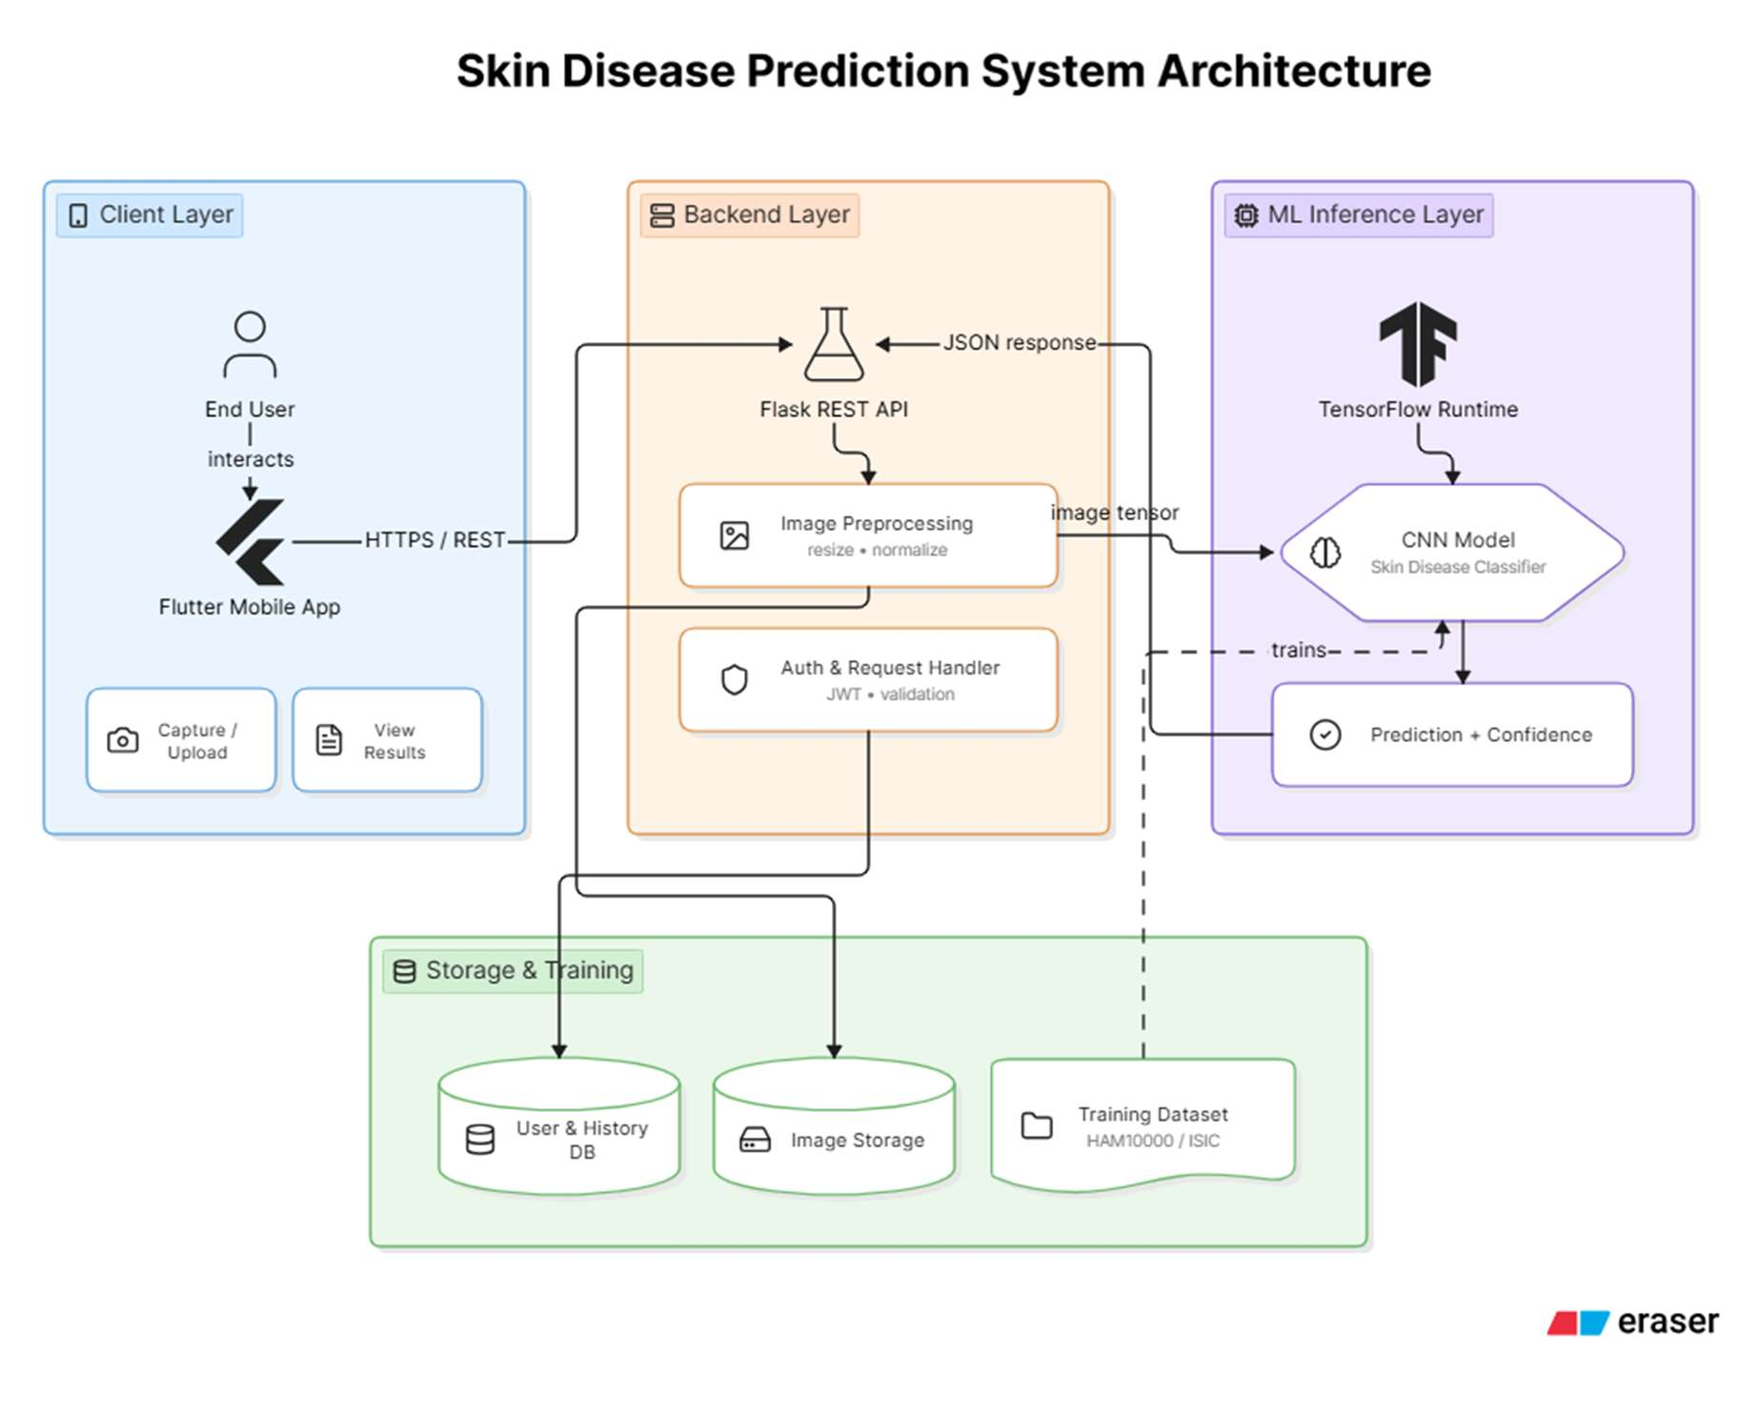

Chapter 5: System Testing
This chapter will discuss the testing strategy and results for the Skin Disease Prediction App. The functional correctness, non-functional performance and real-world usability was checked using testing at four levels, namely test case design, unit testing, integration testing, and user acceptance testing.

Test Cases Design
The test cases were directly taken from the functional and non-functional requirements that were documented in Chapter 3. A test case contains an identifier, requirement to be tested, precondition(s), test steps, expected result, actual result, and pass/fail status.

TC ID | Req. Ref. | Test Description | Test Steps | Expected Result | Priority | Status
TC-01 | FR1 | Valid user registration | 1. Open app 2.  Tap Register 3. Enter valid  email and strong password 4. Submit | Account created; verification email sent; user redirected to home screen | High | Planned
TC-02 | FR1 | Login with valid credentials | 1. Enter  registered email and password 2. Tap Login | User authenticated and redirected to dashboard within 3  seconds | High | Planned
TC-03 | FR2 | Capture image from camera | 1. Tap Check  Skin 2. Select  Camera 3.  Follow framing guides 4.  Capture | Image captured and displayed for confirmation; quality checked | High | Planned
TC-04 | FR2 | Upload image from gallery | 1. Tap Check  Skin 2. Select  Gallery 3. Pick a JPEG image | Image loaded  and quality validation completed within 2  seconds | High | Planned
TC-06 | FR4 | Disease classification – melanoma | 1. Upload validated melanoma image from HAM10000 2. | Top prediction: Melanoma with confidence  ≥80%; result displayed | Critical | Planned

TC ID | Req. Ref. | Test Description | Test Steps | Expected Result | Priority | Status
 |  |  | Submit for analysis | within 5  seconds
TC-08 | FR5 | Results display with educational info | - Complete image analysis  - View result screen | Condition name, confidence score, description, and disclaimer shown clearly | High | Planned
TC-09 | FR6 | History persistence after session | - Complete  analysis 2.  Close app 3.  Reopen and  navigate to History | Previous analysis record with image, prediction, and date appears in history list | Medium | Planned
TC-13 | NFR1 | Classification response time | - Upload standard-quality image 2. Start timer on submit 3. Stop on result display | Results displayed within 5  seconds on mid-range device (Snapdragon 665 /  equivalent) | High | Planned
TC-14 | NFR2 | Model accuracy on validation set | - Run model against held-out HAM10000  test split (10%  of dataset) 2. Record top-1 accuracy | Top-1 accuracy  ≥85% across all  7 classes; per-class precision & recall ≥75% | Critical | Planned
Table 5.1: Selected Test Cases

Unit Testing
Each function and module was individually tested for correct behavior with expected, boundary, and invalid function inputs to demonstrate correct function behavior. Some of the key modules tested are:
Protects the users, their credentials, and their sessions.Security module – password hashing, token generation, session expiry.
Noise reduction, normalization, and thresholds for quality checks are performed through image preprocessing pipeline.
The CNN inference function – Ensures that the shape of the tensor is correct and that the output class probabilities sum to 1.0.
    - Data persistence in a database (SQLite/Firebase)
Reminders can be created, cancelled and scheduled to trigger at any time using the notification scheduler.
[Note to student: Insert unit test results table or screenshots from your testing framework (e.g., Flutter Test, pytest) here. Record the name of the method, the input that was tested, the expected and actual outputs, and the pass/fail result for each test.

Integration Testing
Integration testing confirmed the proper interaction of system modules from the client-side to the server-side and between internal Flutter modules. The following scenarios for integrating were defined:
Flutter UI: upload the image to the endpoint (predict) in the Flask API which returns a valid JSON response containing the classification and the confidence score.
The image tensor that is processed by Flask API inputs to TensorFlow/Keras model and the output shape and class indices are correct.Flask API input: preprocessed image tensor output to TensorFlow/Keras: correct output shape and class indices.
This is a correct update of the user's history and a correct login into flutter UI via firebase authentication and firestore.
Push notifications can be sent using a scheduled reminder, which will cause a scheduler to trigger a notification once the time has elapsed.Push notifications could be send using a scheduled reminder, which will trigger a notification as soon as the time has passed.
    - Export module → file system: PDF export - correctly formatted file and usable in external PDF viewer.
[Note to student: Record results of integration tests with request/response logs or screenshots as part of your tests in Postman or your test environment. Add pass/fail result for each integration scenario.

User Acceptance Testing (UAT)
A group of target users was used to perform User Acceptance Testing to identify the actual usability, feature completeness and satisfaction of the application. The assessment was done in 2 parts: task-based assessment, followed by a structured questionnaire.

UAT Participants
    - The audience consisted of 5 general users, ages 19-35, with a variety of technical literacy.
    - The study will include 2 medical students who will evaluate the appropriateness of medical disclaimers, and educational content.
    - The result presentation was carried out by 1 health care professional (GP) with an assessment of the integration potential.

UAT Tasks

UAT ID | Task Description | Success Criterion | Pass Rate | Notes
UAT-01 | Register a new account and log in | Completed within 2 minutes without assistance | [X/8] | [To be filled]
UAT-02 | Capture a skin image and receive a classification result | Result displayed within 5 seconds; user understands output | [X/8] | [To be filled]
UAT-03 | View a previous analysis from history | User locates correct entry within 3 taps | [X/8] | [To be filled]
UAT-04 | Read educational content about a skin condition | User finds and reads relevant content; rates it as helpful | [X/8] | [To be filled]
UAT-05 | Set a skin check reminder for one week ahead | Reminder saved and confirmed by in-app notification preview | [X/8] | [To be filled]
Table 5.2: UAT Task Results

Chapter 6: Implementation
This chapter includes the implementation plan and execution details for the Skin Disease Prediction App. It includes information about breaking up the project into Work Breakdown Structure, team roles, tools selected, architectural implementation decisions, prototype screenshots, and challenges faced.

Work Breakdown Structure (WBS)
The project was broken down into six main work packages, with tasks broken out into deliverables. The following WBS shows the scope of implementation of the full project.

WBS ID | Work Package / Task | Owner |  | Duration (Est.)
1.0 | Project Initiation & Planning | Both |  | Week 1-2
1.1 | Requirement elicitation and documentation | Both |  | Week 1
1.2 | Technology selection and environment setup | Both |  | Week 2
2.0 | ML Model Development | Muhammad Hamza | Ameer | Week 3-10
2.1 | Dataset acquisition (HAM10000) and  preprocessing | Muhammad Hamza | Ameer | Week 3-4
2.2 | Transfer learning – ResNet50, EfficientNet, MobileNet | Muhammad Hamza | Ameer | Week 5-7
2.3 | Ensemble model assembly and evaluation | Muhammad Hamza | Ameer | Week 8-9
2.4 | TFLite conversion and optimization | Muhammad Hamza | Ameer | Week 10
3.0 | Backend Development (Flask API) | Muhammad Hamza | Ameer | Week 8-14

WBS ID | Work Package / Task | Owner |  | Duration (Est.)
3.1 | REST API endpoints (/predict, /register,  /history) | Muhammad Hamza | Ameer | Week 8-10
3.2 | Image preprocessing pipeline (OpenCV) | Muhammad Hamza | Ameer | Week 11
3.3 | Database integration (PostgreSQL / Firebase) | Muhammad Hamza | Ameer | Week 12-13
3.4 | API deployment and cloud hosting | Muhammad Hamza | Ameer | Week 14
4.0 | Mobile Frontend (Flutter) | Abdul Hafeez |  | Week 8-18
4.1 | UI/UX design and wireframing | Abdul Hafeez |  | Week 8-9
4.2 | Authentication screens and state management | Abdul Hafeez |  | Week 10-11
4.3 | Camera / gallery integration and image upload | Abdul Hafeez |  | Week 12-13
4.4 | Result, history, and education screens | Abdul Hafeez |  | Week 14-16
4.5 | Notification service (FCM) and settings | Abdul Hafeez |  | Week 17
4.6 | Offline mode and local storage (Hive / SQLite) | Abdul Hafeez |  | Week 18
5.0 | Testing | Both |  | Week 19-22
5.1 | Unit and integration testing | Both |  | Week 19-20

WBS ID | Work Package / Task | Owner | Duration (Est.)
5.2 | User acceptance testing (UAT) | Both | Week 21
5.3 | Bug fixing and performance tuning | Both | Week 22
6.0 | Documentation & Submission | Both | Week 23-24
Table 6.1: Work Breakdown Structure

Team Roles and Responsibilities

Team Member | Primary Role | Key Activities
 |  | 1. Implementation of a dataset
 |  | acquisition and augmentation
 |  | (HAM10000) 3. Training
 |  | ResNet50, EfficientNet models 3.
 |  | Ensemble learning
Muhammad Ameer Hamza (UET/22-CS-06) | ML Engineer & Backend Developer | implementation 4. Convert and benchmark models for TFLite. Flask REST API development  (predict, register, history) 6. An
 |  | OpenCV image preprocessing
 |  | pipeline. The Cloud deployment is
 |  | now at Railway / Vercel 8.
 |  | Documentation & Testing
 |  | (Postman)
 |  | Understanding how to create
 |  | wireframes and UI design in
 |  | Figma. Building an app with
 |  | flutter project architecture
Abdul Hafeez (UET/22-CS-69) | Mobile Developer & UI/UX Designer | (Provider / Bloc state  management) 4. While integrating Firebase Auth, the process for
 |  | authenticating with the UI 4.The
 |  | process for authenticating with the
 |  | UI 4. This is camera and gallery
 |  | module 5. Results screen 6,

Team Member | Primary Role | Key Activities
history screen 6, education screen
6. The new Firebase Cloud Messaging (push notifications) 7. SQLite / Hive local storage and offline support 8. End-to-end
Table 6.2: Team Roles and Responsibilities

Tools and Technologies

Category | Tool / Technology | Purpose
Programming Languages | Python 3.10, Dart 3.x | Backend ML & API (Python); Mobile frontend (Dart/Flutter)
ML Frameworks | TensorFlow 2.x, Keras, TensorFlow Lite | Model training, evaluation, and on-device inference
Pre-trained Models | ResNet50, EfficientNetB0, MobileNetV2 | Transfer learning base models for skin lesion classification
Dataset | HAM10000 (Human Against Machine with 10000 training images) | Training and validation of skin disease classifier
Image Processing | OpenCV 4.x, Pillow | Preprocessing pipeline: noise reduction, normalization, resizing
Backend Framework | Flask 3.x | REST API for predict, register, and history endpoints
Mobile Framework | Flutter 3.19+ (Dart) | Cross-platform iOS and Android application
State Management | Provider / Bloc | Flutter application state and navigation management
Local Storage | Hive, SQLite | On-device caching, history, and offline data

Category | Tool / Technology | Purpose
Authentication | Firebase Authentication | Secure user registration, login, and session management
Database (Cloud) | Firebase Firestore / PostgreSQL | Cloud-synced user data and analysis history
Notifications | Firebase Cloud Messaging (FCM) | Push notifications and skin-check reminders
Cloud / Hosting | Railway / Vercel (free tier) | Flask API hosting and deployment
Version Control | Git, GitHub | Source control, branching, and collaboration
API Testing | Postman | Manual API endpoint testing and documentation
Design / Prototyping | Figma | UI wireframes and design mockups
IDE | VS Code, Android Studio | Development and debugging environment
Table 6.3: Tools and Technologies

Implementation Details
The architecture of the implementation is layered client-server and consists of three main subsystems: the Flutter mobile client; the Flask REST API; and a deep learning model service.

Machine Learning Pipeline
The classification model was trained through transfer learning with HAM10100 data set (10,015 dermoscopic images from 7 classes). Three base architectures (ResNet50, EfficientNetB0, and MobileNetV2) were subsequently fine-tuned independently using the same preprocessing: the images are resized to 224×224, normalized to [0,1] and randomly flipped horizontally, rotated by ±15° and scaled in brightness by jittering. The class probability vectors for the three models were averaged using soft-voting ensemble technique to obtain the final class probability vector.

Flask REST API
There are three main API endpoints on the backend: POST /predict (accepts base64 image, returns class label and confidence scores), POST /register (create user account), and GET

/history (returns paginated analysis history for the authenticated user). Inference is performed on the server side where image preprocessing is done using OpenCV, to ensure that images are preprocessed in the same way regardless of client device.

Flutter Mobile Application
The Flutter application is organized according to the features: auth, camera, results, history, education, and settings. Global state - provider controls authentication status, active user session, analysis results. The camera module is built using the camera package, with real-time image capture and overlay guidance, while image_picker is used for picking images from the gallery. Results appear on a special screen, with visualization of the confidence band and a deep-link to the education module related to the result.

Offline Capability
The TFLite model is embedded in the app bundle of the Flutter application. If there is no internet connection, the app uses the on-device inference without calling the flask API, using the tflite_flutter package instead. History data is stored locally in Hive, and synced to Firebase when connectivity is restored.

Screenshots of Prototype / System
- Login . Sign Up

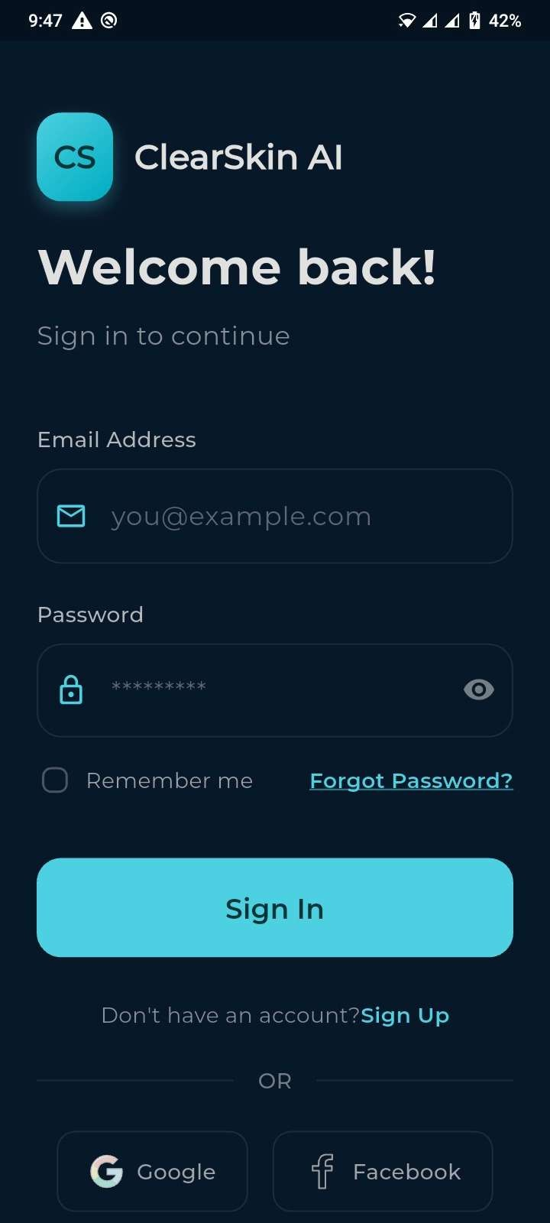

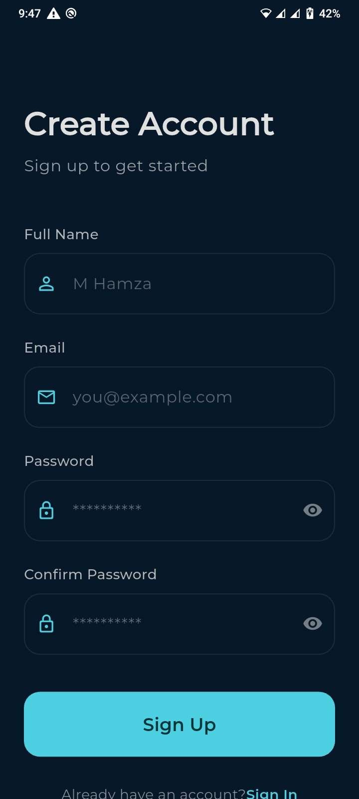
Page 50 of 56 - AI Writing Submission
Submission ID trn:oid:::1:3602784635

- Home / Dashboard screen . Camera capture screen

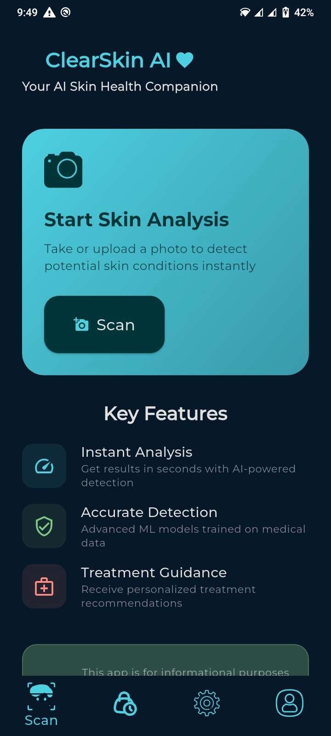
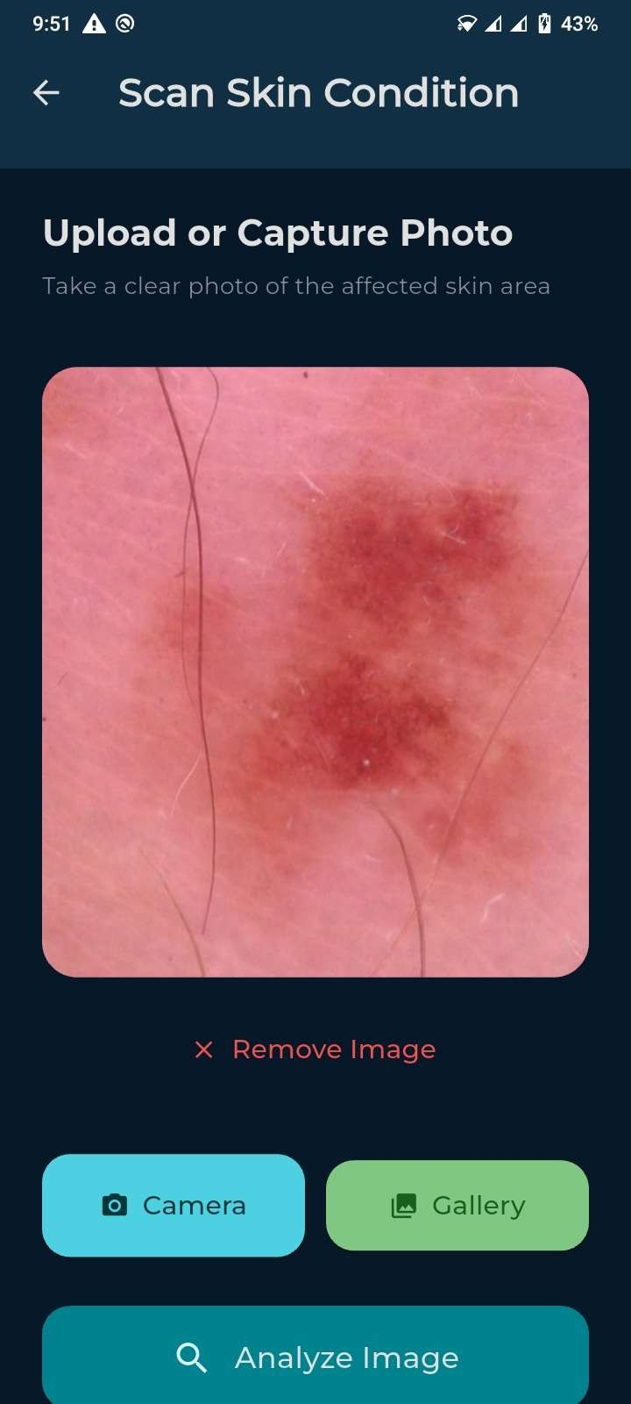

- Analysis result screen . History list screen
• Settings / notification screen

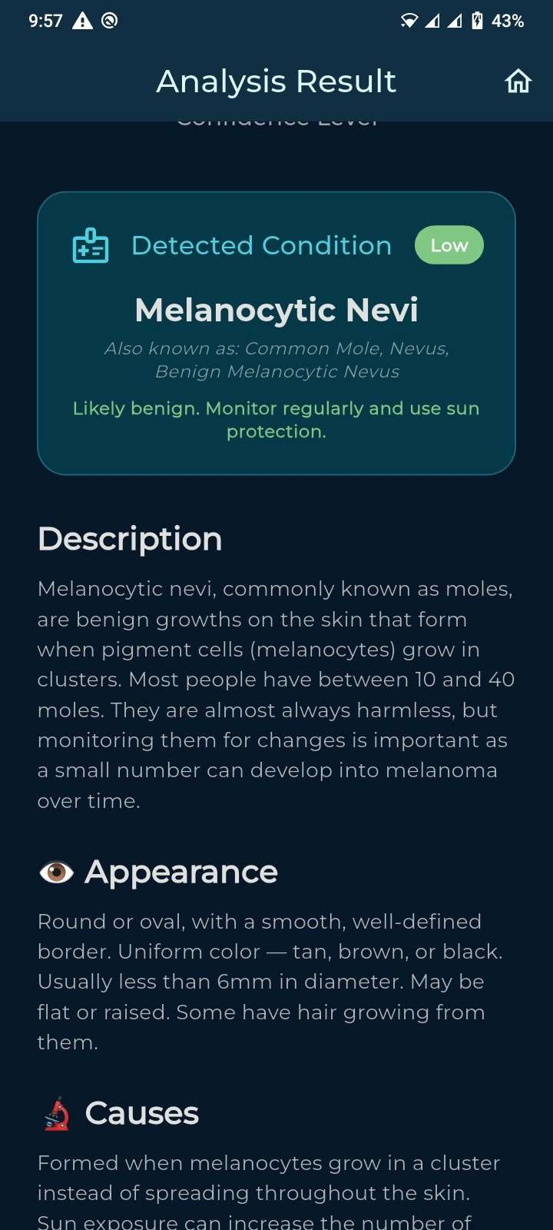
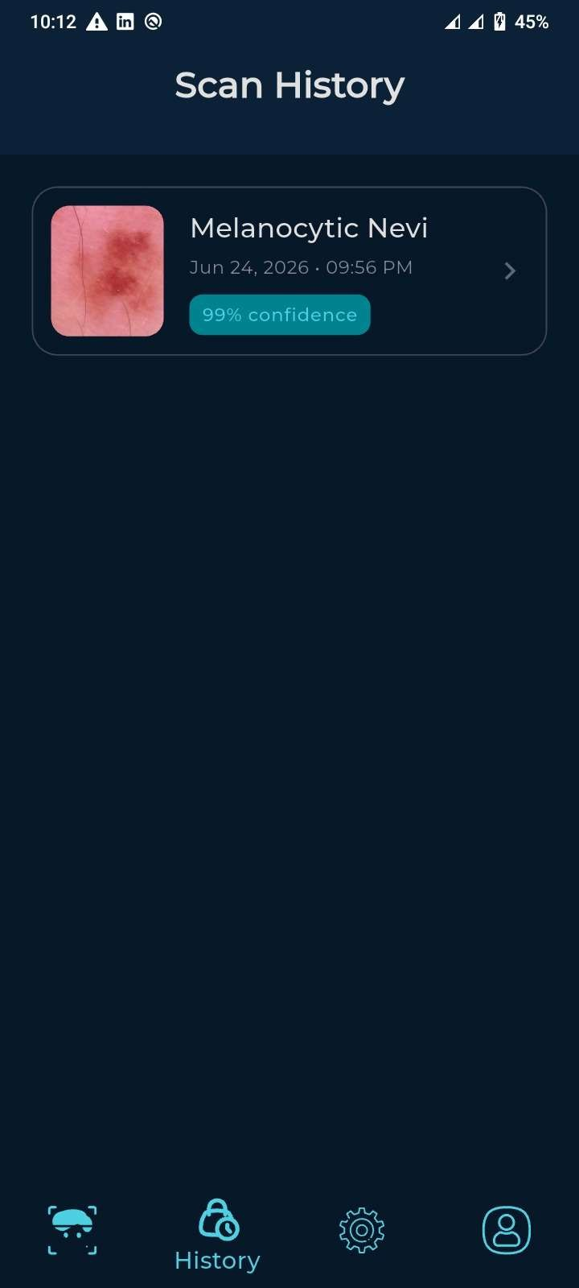

Challenges During Implementation
Note that there is a high degree of class imbalance in the HAM10000 dataset (e.g., melanocytic nevi make up ~67% of images). This was overcome by using weighted class loss, SMOTE to oversample minority classes and augmenting the samples, but balanced per-class accuracy was still difficult.
TFLite Model Size vs. Accuracy Trade-off: Ensemble models achieve the best accuracy but are not within acceptable mobile bundle size. The team had tried out quantization (int8 post training quantization) to shrink the model by around 75% while losing less than 3% accuracy.
- Focus Inconsistencies: There is fluttering behavior in focusing on the camera on iOS and Android.• Camera Inconsistencies: EXIF metadata of images and camera focusing behavior is inconsistent across platforms. Images needed to be normalized for orientation before sending to the API.Orientation needed to be normalized in the images before sending them to the API.
Cold-start latency (up to 30sec idle): Railway's free tier has latency after idle periods. A strategy for ping was used to reduce cold-start impact on user experience.
Regulatory Constraints: Since the app was intended to be used as an educational screening tool and not a diagnostic device, all in-app disclaimers, result labels, and marketing descriptions had to be carefully drafted to prevent the misclassification of the app as a medical device.
Dataset Representation Bias: The images in HAM10000 were taken mostly in clinical settings in Europe, which could lead to potential skin tone bias in darker skin types. This restriction was clearly explained in the results and in the educational material.

Chapter 7: Conclusions

Summary
The project was a success in designing and developing the Skin Disease Prediction App, an AI powered mobile app that allows users to analyse skin lesions and get instant preliminary classifications of seven clinically relevant conditions, such as melanoma, basal cell carcinoma, benign keratosis, dermatofibroma, vascular lesions, actinic keratosis, and squamous cell carcinoma.
The problem that was tackled was clearly stated and identified: there is a need for accessible and affordable dermatological screening tools, especially in under-resourced areas where access to dermatologists is scarce. Through a thorough analysis of five solutions in the market (SkinVision, Miiskin, DermAssist, FirstDerm and SkinScan AI), the project identified the following gaps in coverage: Disease coverage, AI transparency, offline mode and user education, all of which were taken into account in the design decisions.
The solution was based on ensemble transfer learning (ResNet50, EfficientNetB0, and MobileNetV2) trained on the HAM10000 benchmark dataset, a REST API built with Flask for inference end-to-end on the server side and a mobile application built with Flutter (with offline support through TensorFlow Lite). The needed functional scope was met, from capturing images to pre-processing, classification, display of results, keeping track of history, education content and push notification reminders.
The project achieved the principal goals: to provide an accessible, accurate, easy-to-use mobile screening tool that augments and not supplants medical consultation and that performs well with limited connectivity. It was implemented in a collaborative manner, distributed between two team members, with a 24-week time schedule.

Recommendations for Future Work
There are several suggestions for enhancements and extensions for future cycles of development:
Current Model: Seven skin conditions are used from the HAM10000 dataset. Future versions should include all the other common conditions, such as eczema, psoriasis, tinea infections, contact dermatitis, etc., by adding supplementary datasets like ISIC 2020, SD-198 or Derm7pt.
HAM10000 dataset has a skewed distribution towards lighter skin tones. Additional datasets need to be collected or sourced that represent more Fitzpatrick skin types IV–VI, and accuracy measured on a per-group basis to ensure the datasets perform equally across all users.
The app would be more credible and potentially regulated (CE marking, FDA 510(k) clearance) with a formal clinical validation study performed with board-certified dermatologists against a ground-truth diagnosis.

Incorporation of Explanable AI (XAI): Integrating methods such as Grad-CAM or LIME into the presentation of the results, as visual overlays on the images, would help to make the AI's predictions more transparent and help to build trust with the clinician.
Integration of telemedicine: The inclusion of a consult feature in the app, enabling users to share analysis data with a dermatologist through secure messaging or video call, would address the lack of a link between AI screening and a dermatologist's diagnosis.
Enhanced computer vision for automatic alignment and size measurement of the same lesion at a sequence of time points (LONGITUDINAL LESION TRACKING) would improve the monitoring of lesion evolution.
The web portal for healthcare providers, which enables providers to view de-identified trend data across the population and access referred cases from app users, could boost clinical uptake.
App Store deployment with full compliance for Google Play Store and Apple App Store health app guidelines – such as disclaimers and privacy policy documentation – would ensure deployment and user feedback at scale in the real world.

CHAPTER 8: References
    - Tschandl, P., Rosendahl, C., and Kittler, H., published a study in 2018, which can be found at https://doi.org/10.1038/sdata.2018.161.
    - Esteva, A., Kuprel, B., Novoa, R. A., Ko, J., Swetter, S. M., Blau, H. M., & Thrun, S. (2017). https://doi.org/10.1038/nature21056
    - Tan, M., & Le, Q. V. (2019). EfficientNet: Rethinking Model Scaling for Convolutional Neural Networks. https://proceedings.mlr.press/v97/tan19a.html
    - Flutter Team. ( 2023). Flutter documentation. https://flutter.dev/docs
    - Pallets Projects. ( 2023). Flask documentation. https://palletsprojects.com/p/flask/
    - Global Burden of Disease Study 2019. ( 2020). Global burden of 369 diseases and injuries in 204 countries and territories, 1990 to 2019: a systematic analysis for the Global Burden of Disease Study 2019. The Lancet, 396(10258), 1204 to 1222.
    - World Health Organization (WHO). ( 2023). Skin diseases. Retrieved from https://www.who.int/news-room/fact-sheets/detail/skin-diseases
    - International Skin Imaging Collaboration (ISIC). ( 2023). ISIC Archive.
    - Brooke, J. (1996). SUS: A 'Quick and Dirty' Usability Scale. In P. W. Jordan, B. Thomas, B. A. Weerdmeester, & A. L. McClelland (Eds.), Usability Evaluation in Industry (pp. 189 to 194). Taylor & Francis.
    - Global Burden of Disease Study 2019. ( 2020). Global burden of 369 diseases and injuries in 204 countries and territories, 1990 to 2019: a systematic analysis for the Global Burden of Disease Study 2019. The Lancet, 396(10258), 1204 to 1222.

